**PROBLEM #1:**

Select frequent words (whose count is equal or greater than 50,000). Hint. Use ‘filter’.

Display the frequent words in descending order. (Hint: ORDER .. BY..DESC)

lines = load 'eBooks/*.txt' as (line:chararray);

words = foreach lines generate FLATTEN(TOKENIZE(line)) as word;

grouped = group words by word;

wordcount = foreach grouped generate group, COUNT(words);

filtered = FILTER wordcount by $1 >= 50000;

ordered_records = ORDER filtered BY $1 DESC;

dump ordered_records;

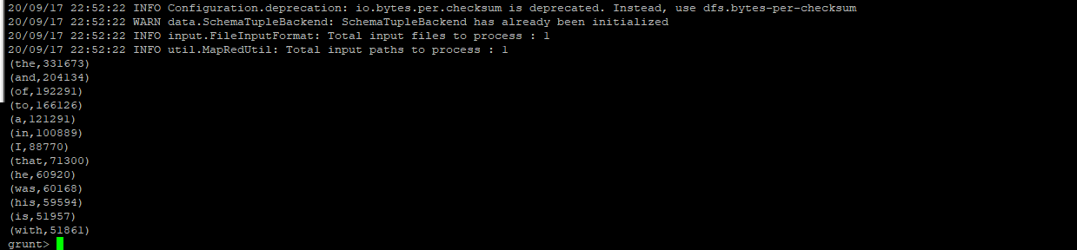

**PROBLEM #2**: → simple change from the above example  
Get groups of words by their length (Hint: use the built-in function SIZE) and count each group.

eg)

grunt> DUMP grouped;  
(1,258.946) → means there are 258946 occurence of words that have one character.

(2,1.096.049) → means there are 1096049 occurence of words that have two characters.

(3,1.444.799)

(4,1.096.414)

(5,711.919)

...

lines = load 'eBooks/*.txt' as (line:chararray);

words = foreach lines generate FLATTEN(TOKENIZE(line)) as word;

grouped = group words by SIZE($0);

wordcount = foreach grouped generate group, COUNT(words);

dump wordcount;

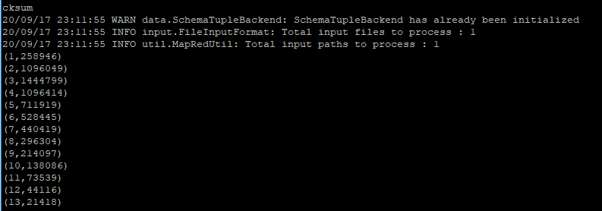

PROBLEM #3:  
Find out the effect of passenger_count on trip_distance, fare_amount, and tip_rate.

(a) Create a new record ‘records2’ that has passenger_count, trip_distance, fare_amount, tip_rate (tip_amount/total_amount)

(b) Filter records2 by passenger_count ( 0 < passenger_count < 10 ) and create ‘records3’

(c) Group records3 by passenger_count.   
(d) Display the average trip_distance, average fare_amount, and average tip_rate per each group of passenger_count.

a)

grunt> rows = load 'nyc_taxi_data_2014.csv' using PigStorage(',');

grunt> records = filter rows by $0 != 'vendor_id';

grunt> records2 = foreach records generate $3 as passenger_count, $4 as trip_distance, $12 as fare_amount,($15/$17) as tip_rate;

grunt> DESCRIBE records2;

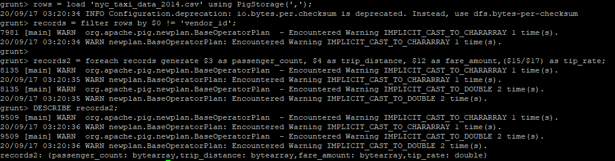

b)

grunt> records3 = filter records2 by (passenger_count >0) AND (passenger_count<10);

grunt> DESCRIBE records3;

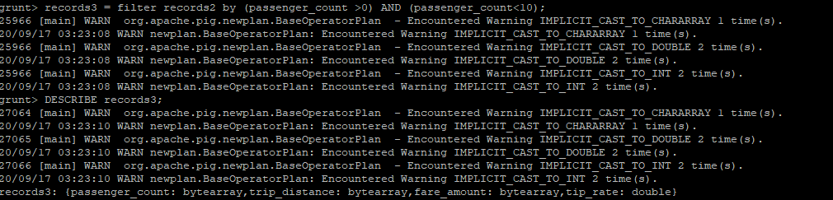

c)

grunt> group_passengers = group records3 by passenger_count;

grunt> DESCRIBE group_passengers;

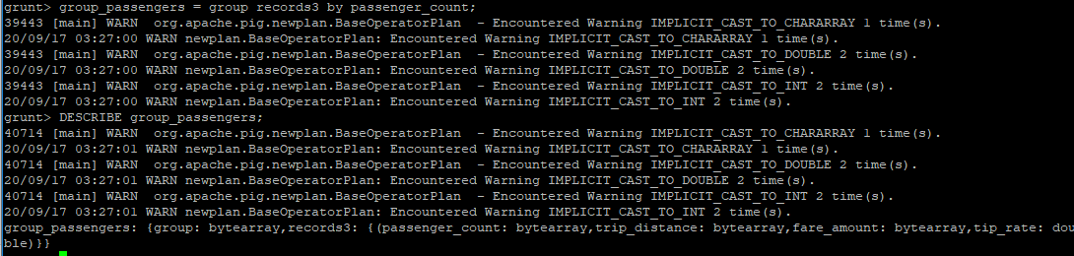

d)

grunt> final_result = foreach group_passengers generate group, AVG(records3.trip_distance), AVG(records3.fare_amount),AVG(records3.tip_rate);

grunt>DUMP final_result;

